Proposed architecture overiew

Proposed architecture

Use React.js or Next.js for deployment.

- The public marketing website is the first thing visitors see.
- The client dashboard is where customers can order and manage their content.
- The writer dashboard lets writers find work and submit their content.

Client features
- Content ordering provides a simple, user-friendly form for clients to submit content requests, also called briefs. The form includes fields for the following information: Content Type (such as Blog Post, Web Copy, etc.), Title, Description, Target Audience, Tone of Voice, Keywords, Calls to Action (CTAs), and any relevant reference links.
- Ability to set deadlines and priorities.
- Submission Review- A queue to review submitted drafts from multiple writers.
- The ability to accept a submission (which triggers payment to the writer), request edits, or decline a piece.
- Project/task commenting and feedback tools for revision requests. Specific writing feedback can be done within Google Docs which we deliver to the client for review with the ability to comment.
- Writer Relationship - A system to "favorite" or "prefer" writers whose work they like. This is our “Pro” feature available for an extra $99 per month.
- Option to send direct assignments to preferred writers.
- A viewable history of all past orders and feedback given to writers.
- Slack account management with dedicated account manager as part of Pro feature for $99 per month.

Account & Billing
- Securely manage payment methods.
- View billing history and download invoices.
- Manage company/personal profile information

Writer Features
- A ranking table for writers: points are awarded for things like number of projects completed, ratings.
- Job Marketplace: A dashboard ("Jobs Board") to view all available “extra overflow” content requests from clients (work not assigned by the manager). Advanced filtering by industry, content type, pay, and client name.
- Payout feature for cashing out money once it becomes available for completed tasks.
1:22

Submission & Workflow

- A system for submitting completed drafts to the client's queue.
- Dashboard to track the status of all submissions (Pending Review, Edits Requested, Accepted, Declined).

Payments & Profile:
- A wallet or earnings summary page showing total earnings.
- Ability to request payouts (e.g., weekly via direct deposit or PayPal).
- A public-facing writer profile showcasing their expertise, industries, and performance stats.

Platform-Wide & Admin Features
Content Categories: All services you listed will be content types clients can order:
- Core: Blog Posts, Articles, Web Copy, LinkedIn Posts, Press Releases, etc.
- Impact: Thought Leadership, Case Studies, SEO Pillar Pages, Video Scripts, etc.

Admin & Manager Dashboard: A back-office portal for platform administrators to:
- Manage users (clients and writers).
- Assign work to writers as they come in each day.
- Oversee content quality and resolve disputes.
- Manage subscription plans and pricing.
- View platform analytics (e.g., total revenue, number of jobs, user growth).
1:25
A single domain is enough , initially users will visit our marketing page, and if they register as client, they will be redirected to clients dashboard and if they are registered as writers , they will be redirected to writers dashboard.

Process & Milestones
Excellent. I’m going to turn your architecture document into a clear, structured project blueprint that:
- Separates responsibilities between:
  - 🧠 Lead Engineer
  - ⚡ Execution & Delivery Engineer
- Breaks work into:
  - Phases
  - Milestones
  - Concrete deliverables
- Keeps it:
  - Easy to understand
  - Execution-focused
  - April 1–driven
This will feel like a real build plan, not theory.

PENNED DASHBOARD – PROJECT BLUEPRINT

High-Level Structure (Single Domain)
As outlined in your architecture :
- Public Marketing Site
- Client Dashboard
- Writer Dashboard
- Admin/Manager Dashboard
- Single domain
- Role-based redirection after login
We will treat this as one application with role-based access control (RBAC).

PHASE 1 – SYSTEM FOUNDATION

🎯 Objective
Establish a stable, scalable core architecture before feature building.

🧠 Lead Engineer Responsibilities

1. Define Core System Architecture
- Choose stack (Next.js + Node + PostgreSQL recommended)
- Define:
  - Auth strategy (JWT / session)
  - RBAC model
  - Database schema
  - Folder structure
  - Deployment strategy

2. Design Core Data Model
Must include:
- Users
  - Role (client, writer, admin)
- Orders
- Submissions
- Revisions
- WriterWallet (ledger-based)
- PayoutRequests
- Subscriptions (Pro plan)
- WriterPreferences (favorite writers)
Deliverable:
- ER diagram
- Order state machine
3. Content Types Catalog
- Seed Core/Impact types
- Admin CRUD (even minimal)
- Ensure order form draws options from DB

⚡ Execution Engineer Responsibilities
- Set up repo
- Scaffold Next.js app
- Create base layout:
  - Marketing page
  - Auth pages
- Connect DB
- Implement role-based redirect after login
Deliverable:
- App running locally + staging
- Auth + role redirect functional

PHASE 2 – CLIENT DASHBOARD

🎯 Objective
Clients can create and manage real content orders.

🧠 Lead Engineer

Define Order Lifecycle
States:
- Draft
- Submitted
- Assigned
- In Progress
- Pending Review
- Revisions Requested
- Accepted
- Declined
- Completed
Define:
- Who can move between states
- Invalid transitions
- Audit logging

Define Pro Feature Logic
- Favorite writers
- Direct assignment
- Slack account manager flag
Feedback History view (past orders + feedback outcomes)
Comment thread per project/submission (even if lightweight)

⚡ Execution Engineer

Build:
- Order Creation Form
  - Content Type
  - Title
  - Description
  - Audience
  - Tone
  - Keywords
  - Deadline
  - Priority
- Order List View
- Order Detail View
- Submission Review Queue
- Accept / Request Edits / Decline logic
- Billing History Page
- Profile Management
- Feedback History view (past orders + feedback outcomes)
- Comment thread per project/submission (even if lightweight)
Google Docs Review Integration
- Store GDoc link per submission
- Client “Open Doc” CTA inside Submission Review Queue
Deliverable:
- Full client flow:
Client → Create Order → Review Submission → Accept

PHASE 3 – WRITER DASHBOARD

🎯 Objective
Writers can find work, submit drafts, and track earnings.

🧠 Lead Engineer
Define:
- Writer Ranking Logic
  - Points system
  - Ratings
- Job Marketplace Logic
  - Assigned vs Overflow
- Wallet Logic
  - Earned vs Available
  - Locked funds
- Payout request rules

⚡ Execution Engineer
Build:
- Jobs Board
  - Filters (industry, type, pay, client)
- Submission Form
- Submission Status Dashboard
- Earnings Dashboard
- Payout Request Page
- Public Writer Profile Page
- Writer Ranking Table page/widget (Leaderboard)
  - Include: points, rating, completed jobs, timeframe filters, tie-break rules
  - We have a Google Sheet to integrate into this ranking system that tracks jobs completed, errors and mistakes, but not ratings, timeframe filters and other point scoring elements
Deliverable:
- Writer can:
  - Accept job
  - Submit draft
  - Track status
  - Request payout

PHASE 4 – PAYMENTS & MONEY SAFETY

🎯 Objective
Money logic is correct and safe.

🧠 Lead Engineer
Design:
- Ledger-based earnings system
  - No direct balance edits
  - Append-only transactions
- Payment trigger:
  - On “Accepted” → earnings move from pending to available
- Idempotency protection
- Admin override rules
- Decide payout rails explicitly (e.g., Stripe Connect Express vs PayPal) and add the corresponding UI fields.

⚡ Execution Engineer
Implement:
- Payment method storage (Stripe recommended)
- Invoice history
- Writer payout request flow
- Admin payout approval
Deliverable:
- End-to-end financial loop safe

PHASE 5 – ADMIN DASHBOARD

🎯 Objective
Penned can operate the platform.

🧠 Lead Engineer
Define:
- Admin permission levels: admin (all permissions), content manager (for manually assigning tasks to writers rather than client selecting, no money permissions or super admin permissions), editor (review all content orders), accountant (money related permissions)
- Manual state overrides
- Dispute resolution workflow

⚡ Execution Engineer
Build:
- Admin user manager, content manager, editor, accountant (see lead above)
- Order reassignment tool
- Subscription management
- Analytics dashboard:
  - Total revenue
  - Jobs completed
  - Active users
Deliverable:
- Penned can manage platform manually

PROCESS STRUCTURE

Weekly Process
- Monday:
  - Lead defines priorities
  - Execution confirms scope
- Midweek:
  - Small PRs
  - No giant merges
- Friday:
  - Demo video or Loom
  - Progress summary in Slack

MILESTONE TIMELINE TO APRIL 1

Week 1
Foundation + DB schema + auth

Week 2
Client order creation + listing

Week 3
Writer jobs board + submission

Week 4
Review + revision loop working

Week 5
Wallet + payout logic

Week 6
Admin tools

Week 7
Hardening + permissions audit

Week 8
UI polish + bug fixes

Week 9
Final testing + deployment

WHAT THE LEAD OWNS
- Architecture
- Data integrity
- Workflow correctness
- Payment safety
- Technical direction

WHAT THE EXECUTION ENGINEER OWNS
- Feature implementation
- UI/UX
- Forms & dashboards
- API wiring
- Iteration speed

Definition of MVP (Critical)
By April 1:
✅ Clients can order
✅ Writers can submit
✅ Revisions work
✅ Acceptance triggers earnings
✅ Payouts can be requested
✅ Admin can intervene
NOT required:
❌ Perfect UI
❌ Advanced analytics
❌ AI features
❌ Automation perfection

First Draft Design
We had started this project a little while back before our developer got into an accident. Not sure if useful or not, but here’s some screenshots of what he had up to that point to give you a rough idea of the direction we were going with it all. You don’t need to copy this in any way, but sometimes I think it can be useful seeing other peoples’ ideas:

Penned.Io First Frontend Prototype
This is a sample draft of the frontend, i want feedback from all and also help with features . I also want to know if i am getting the navigation flow correctly.

Home Page
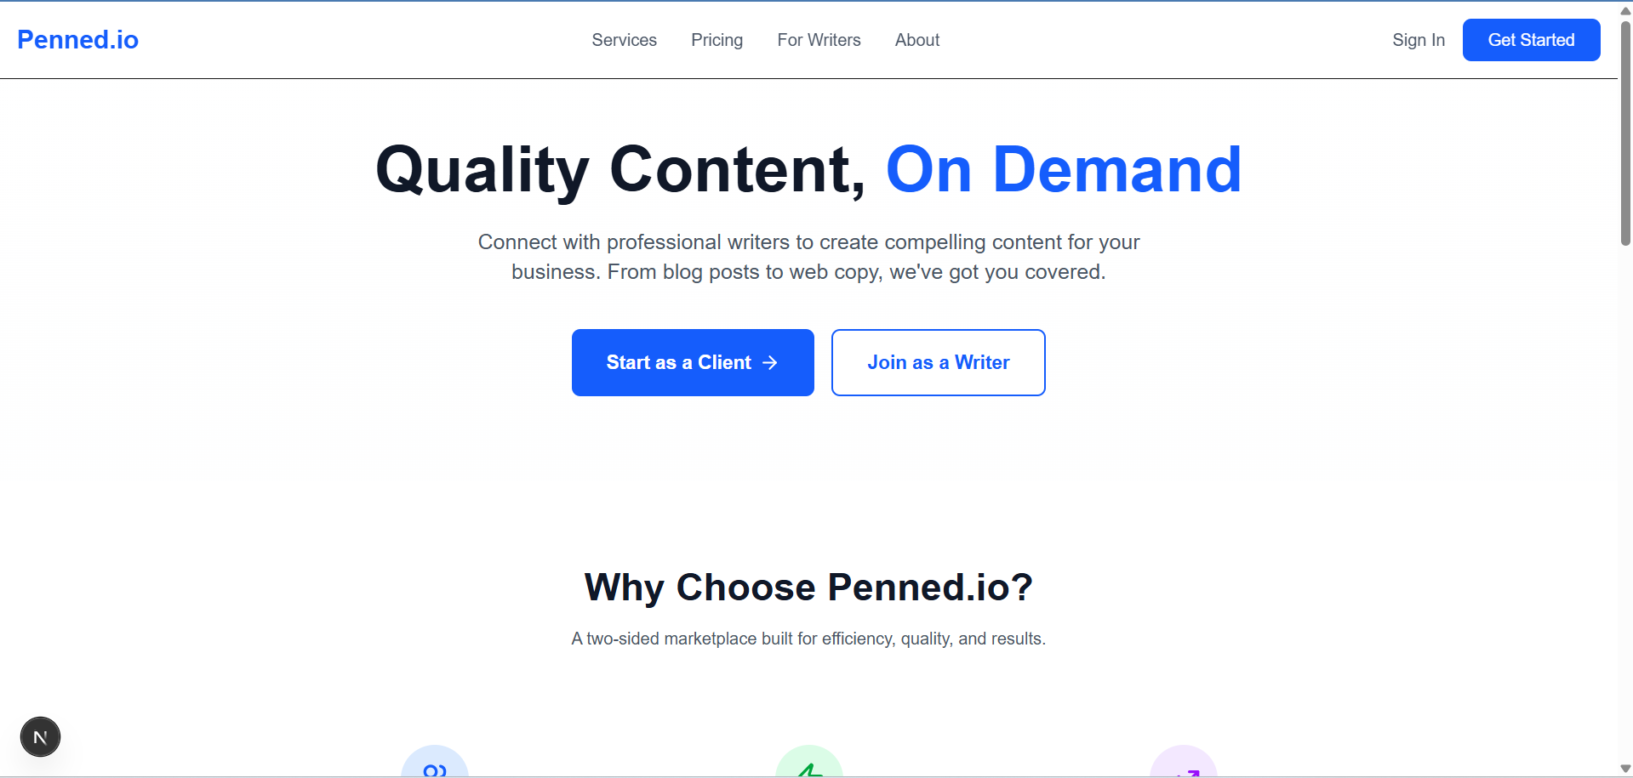

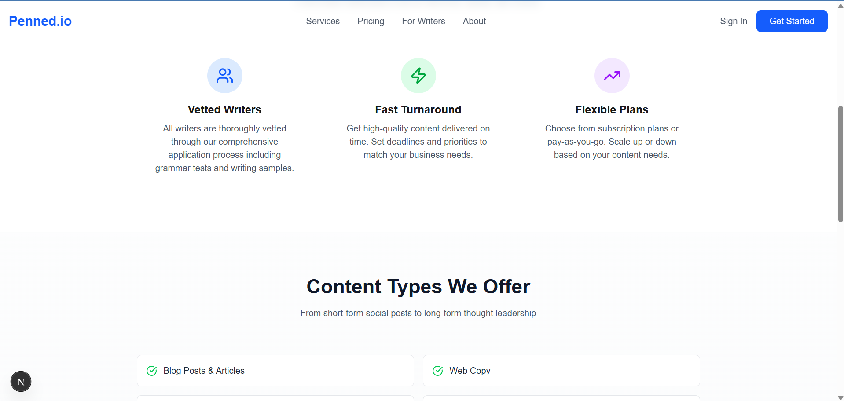
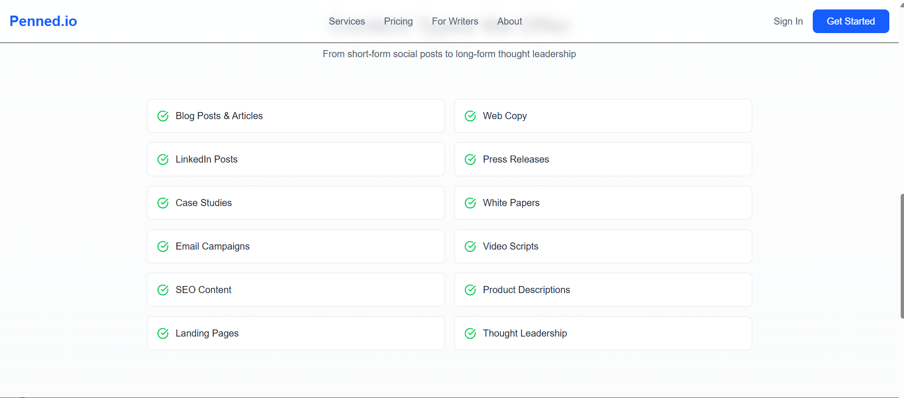

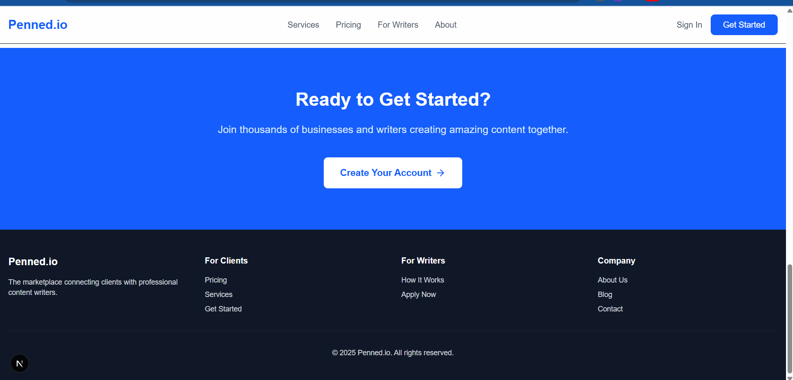

Sign-in for the client
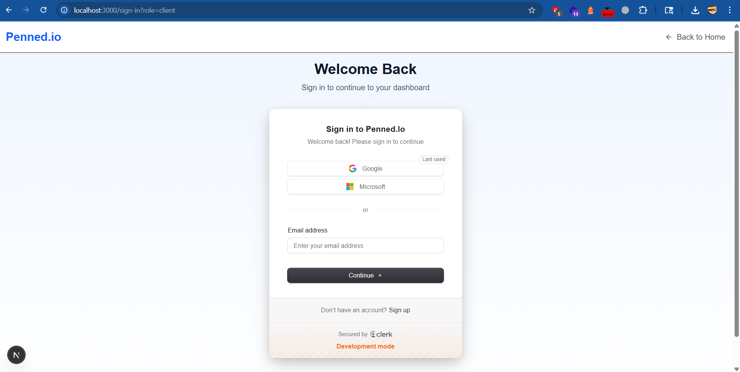

Client Dashboard
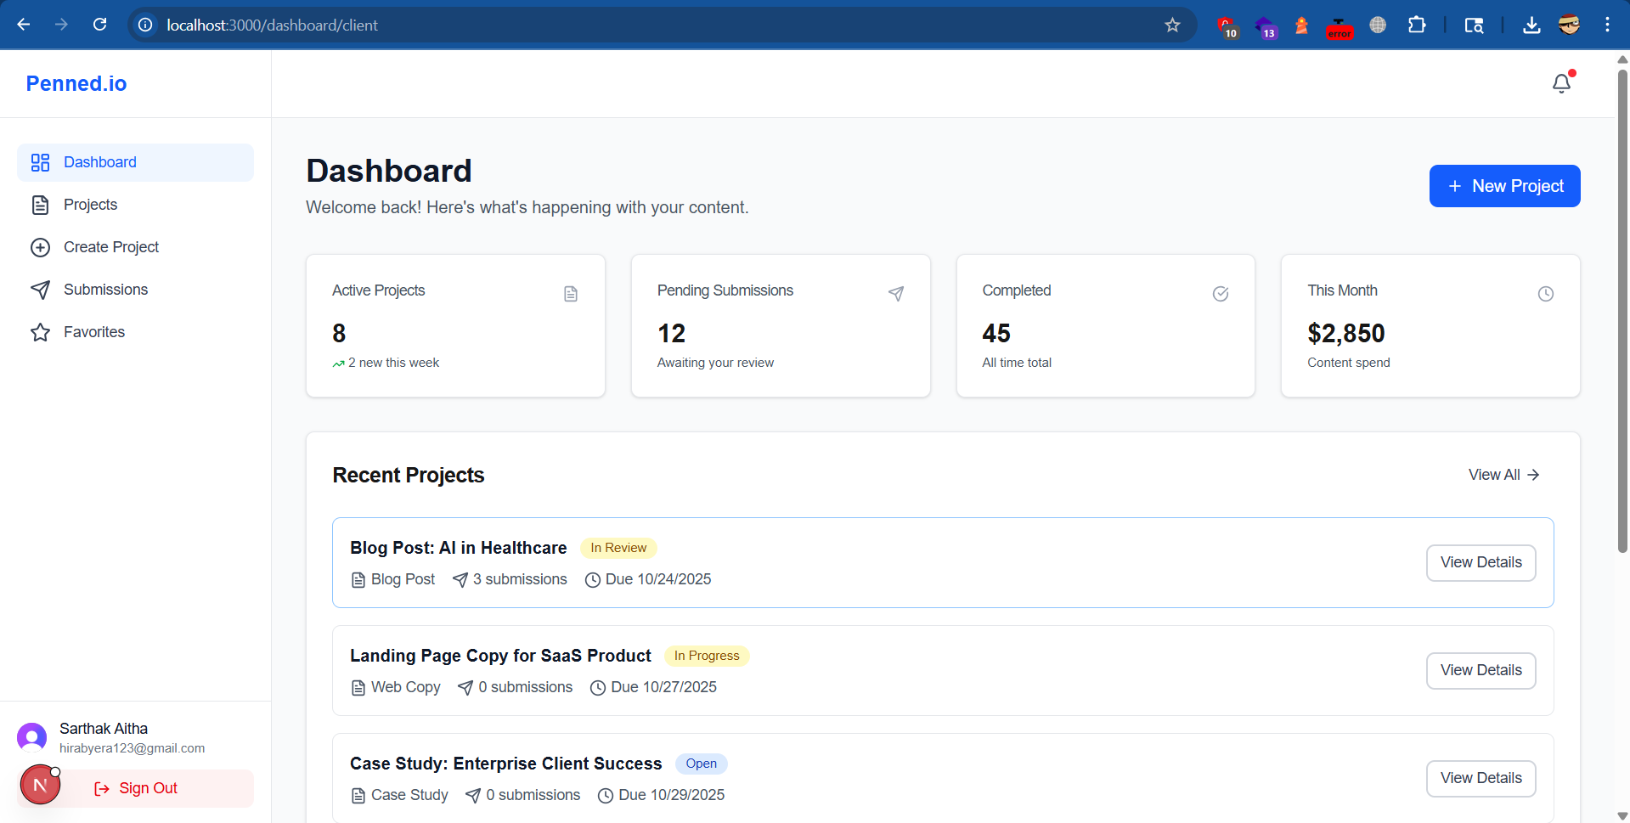
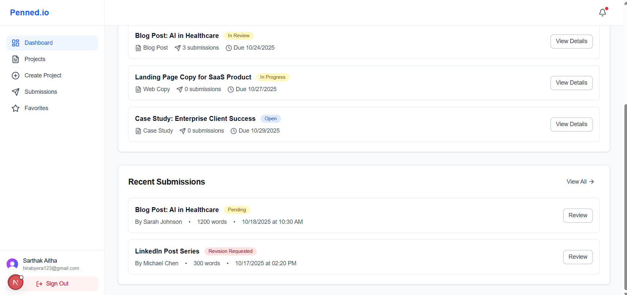

Client Projects
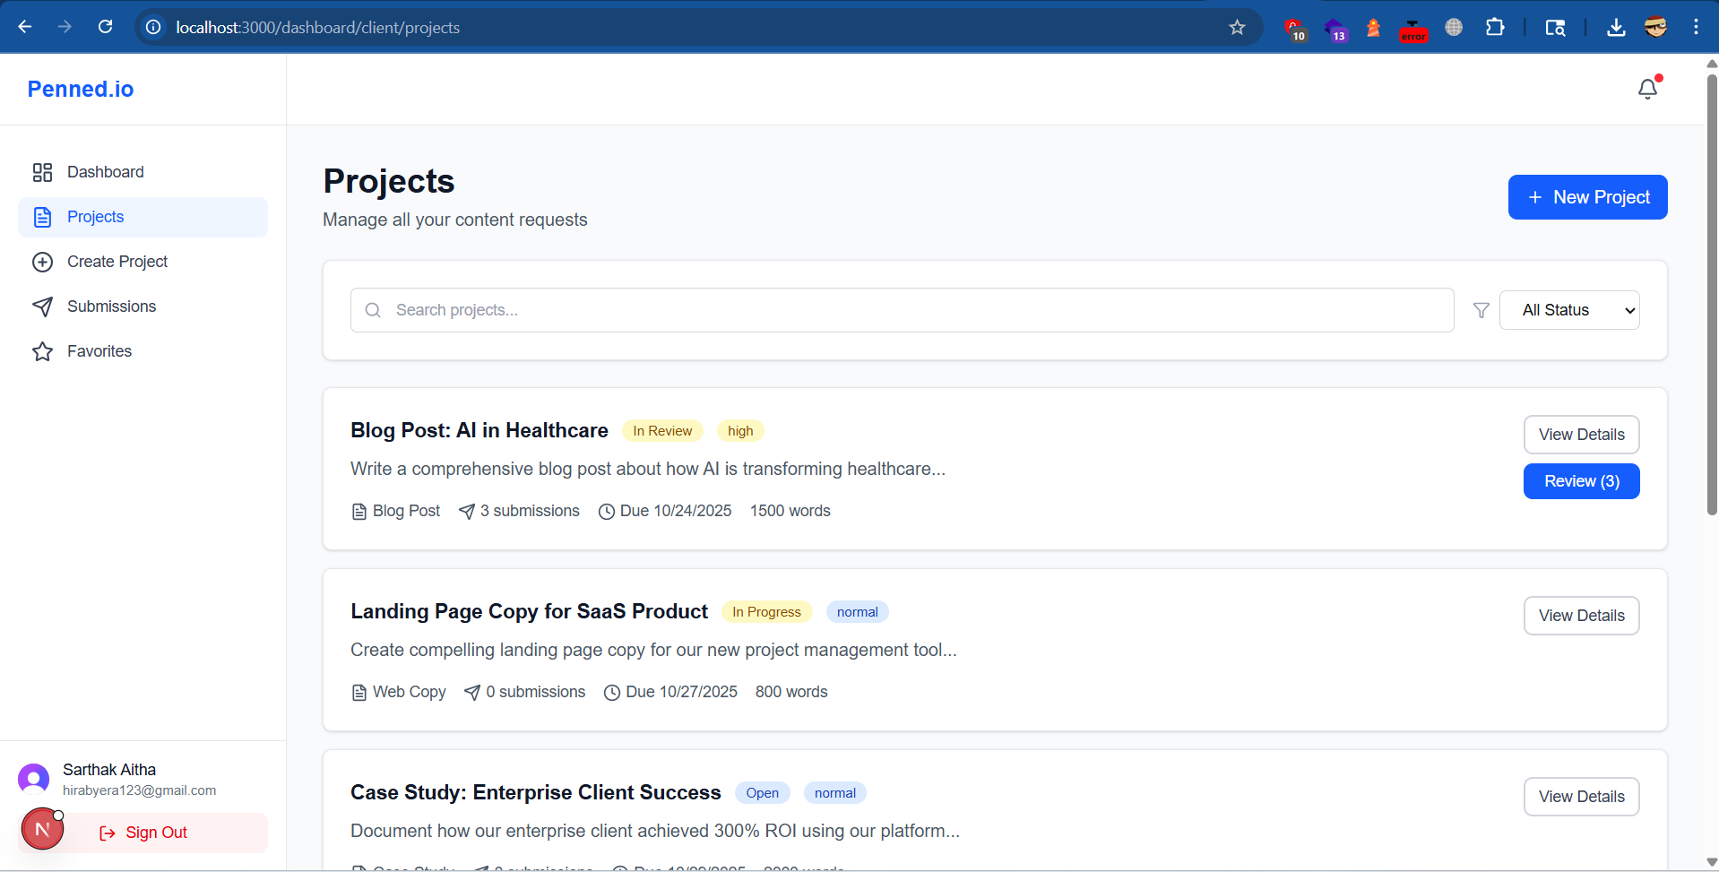

Creating a new project
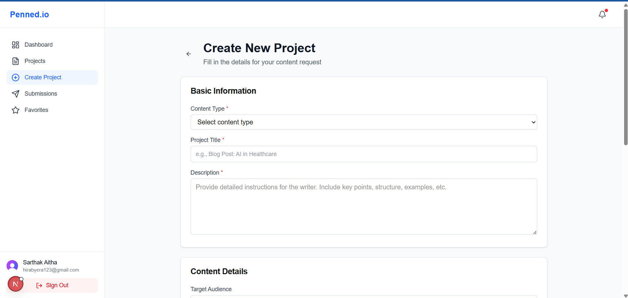
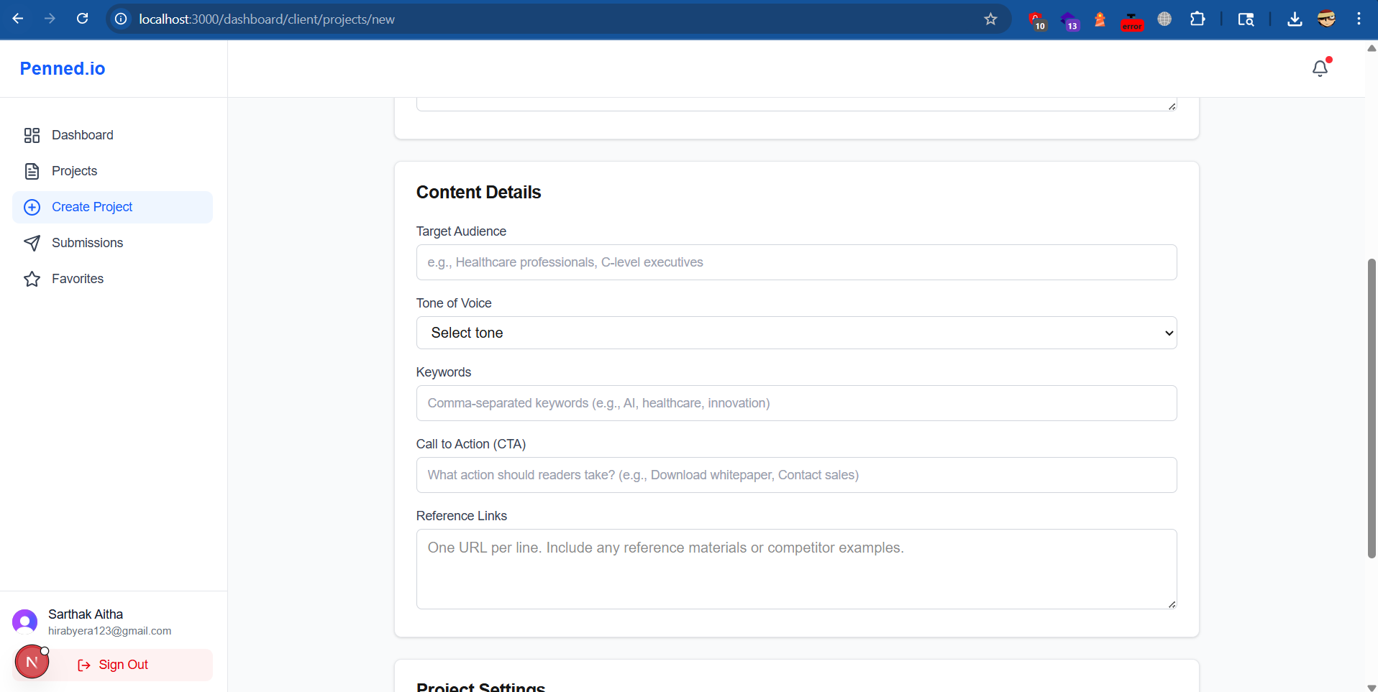
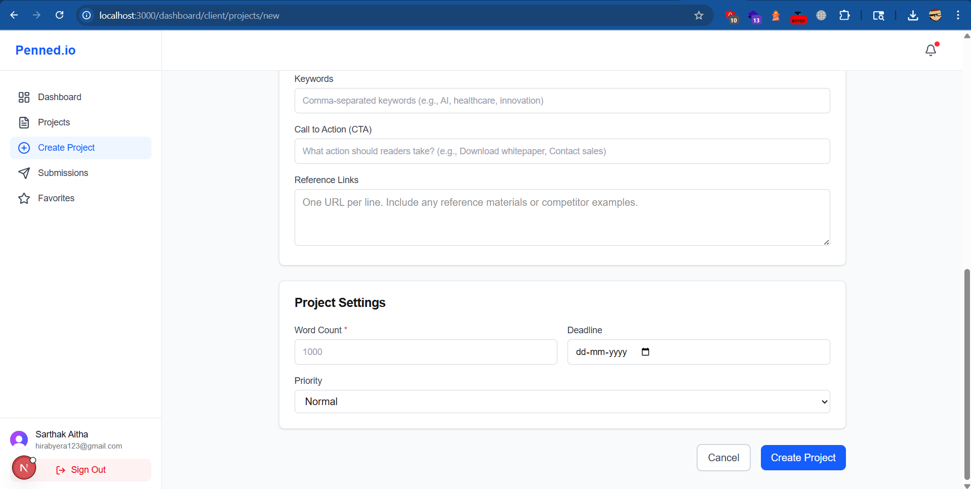

Client Submissions
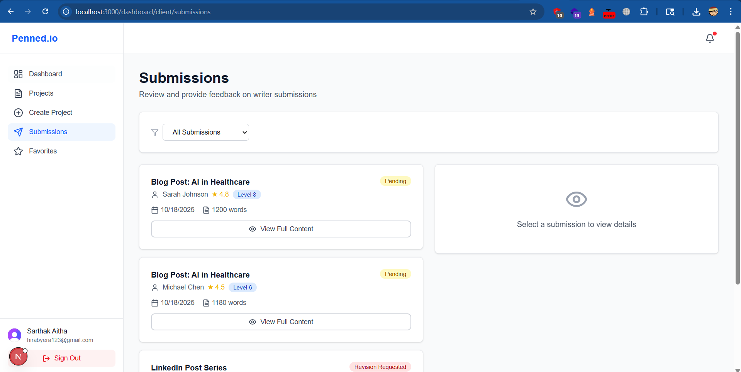

There is also a page where client can save projects to favourites

Writers Marketing Page
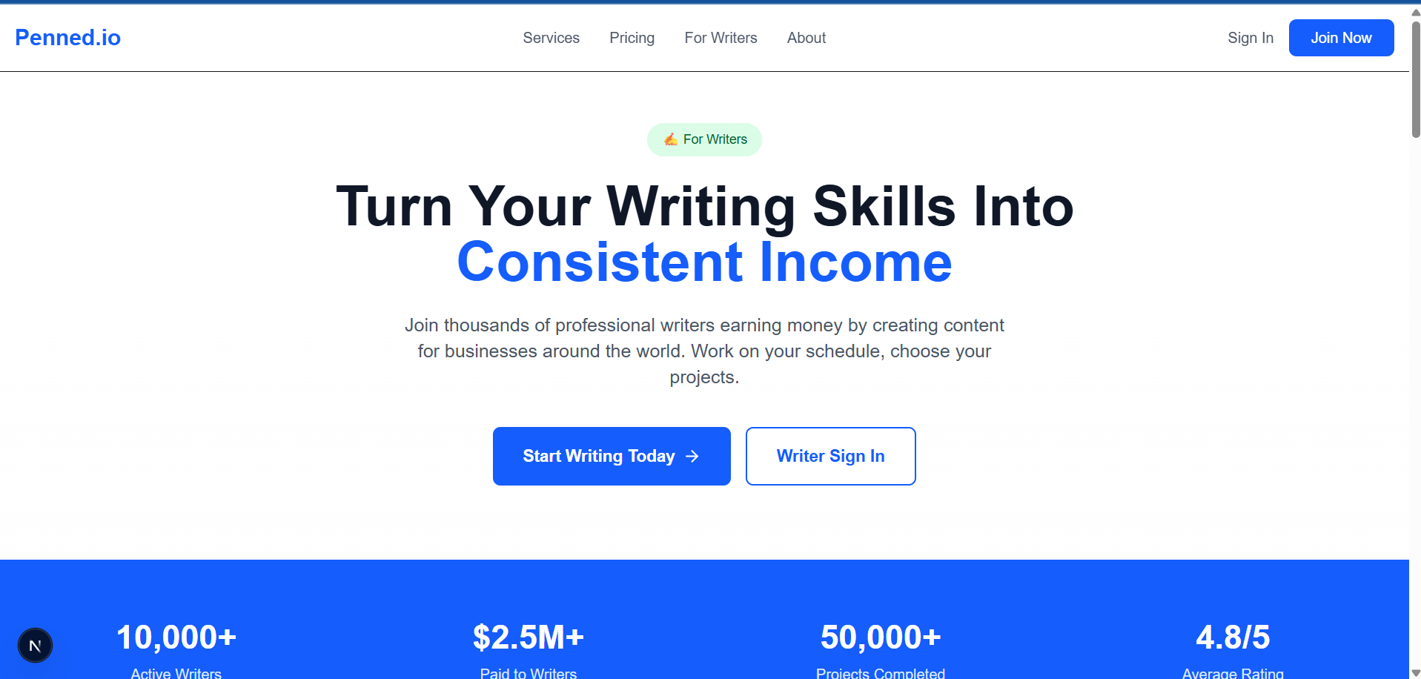

Writers Dashboard
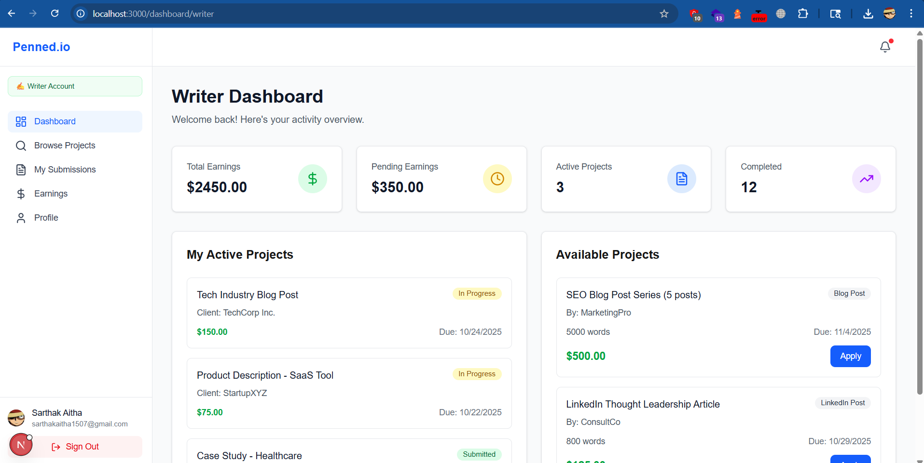

Writers Can Browse for Client’s Projects
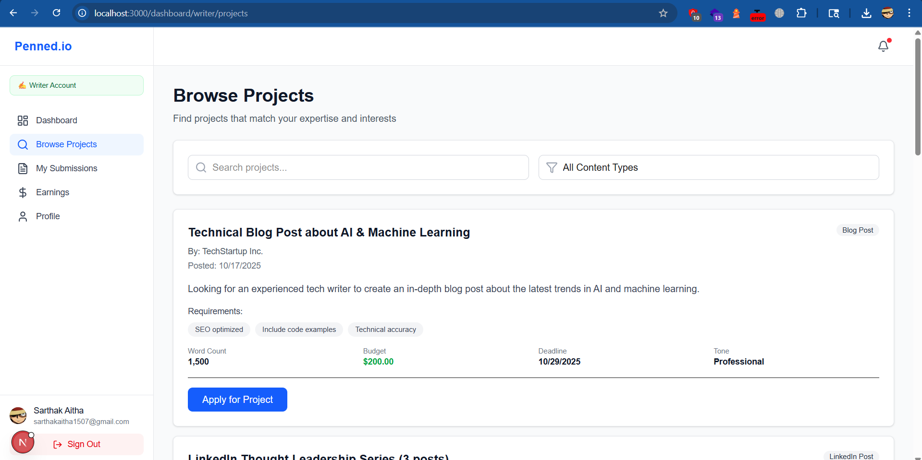

Writers Earning page
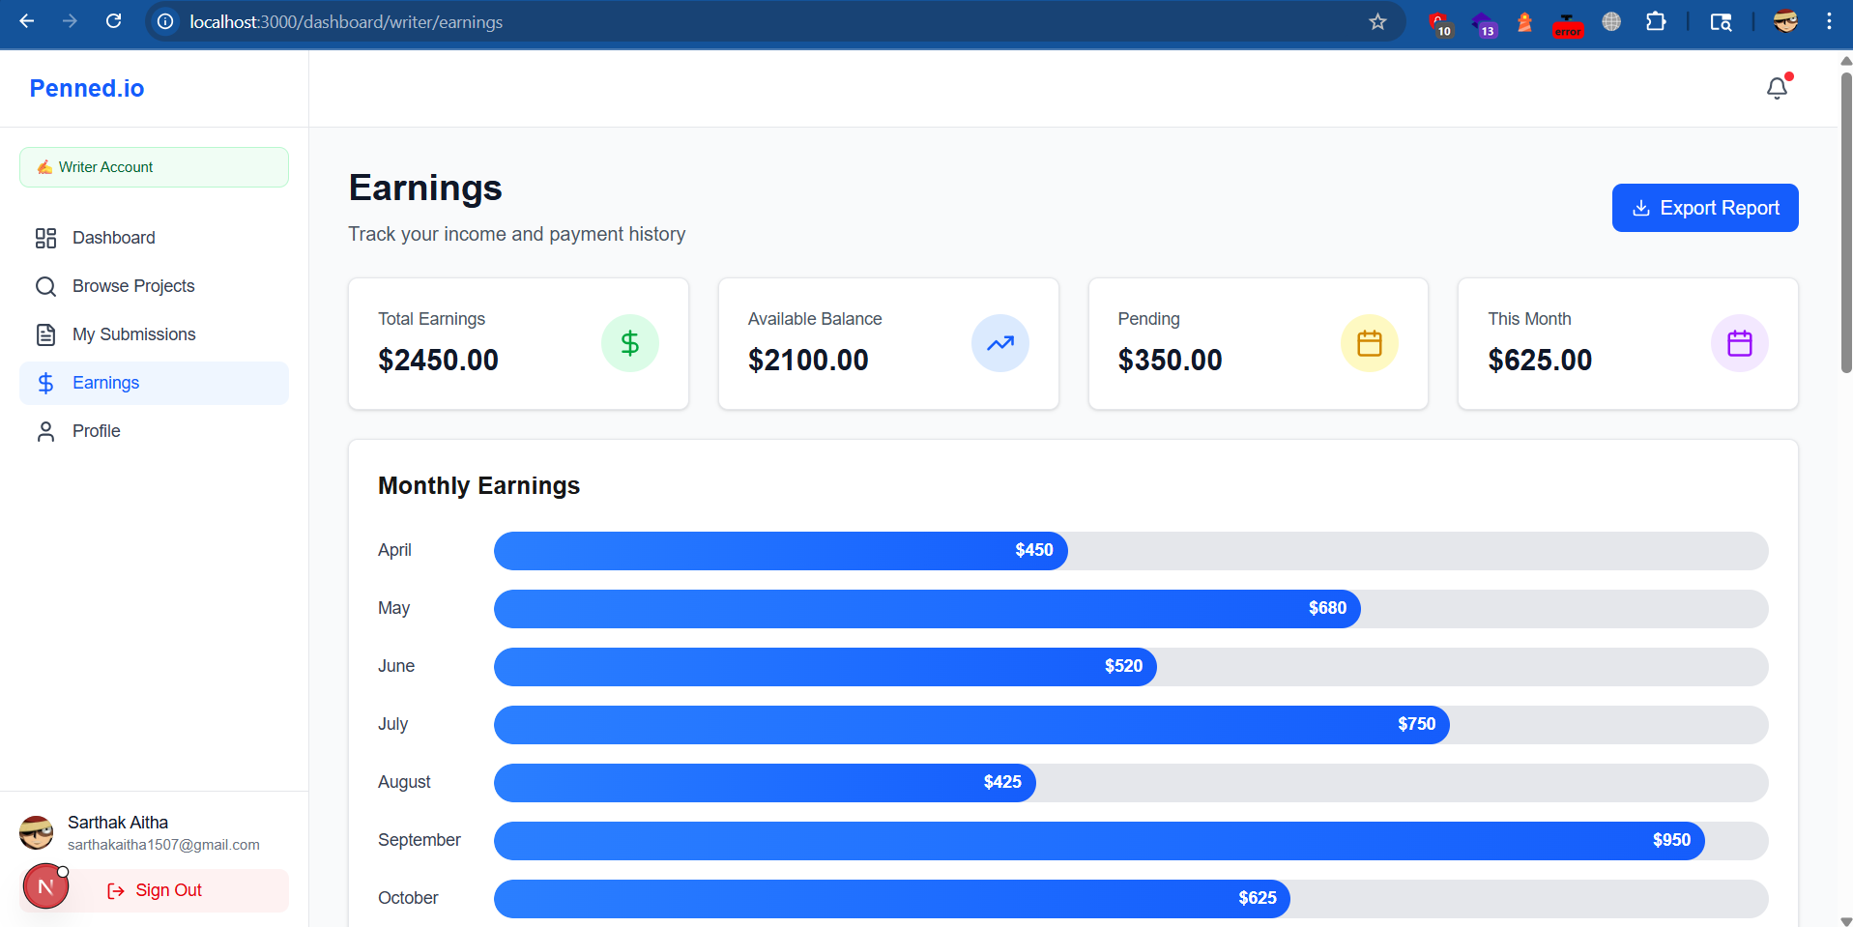

Writers Profile Page
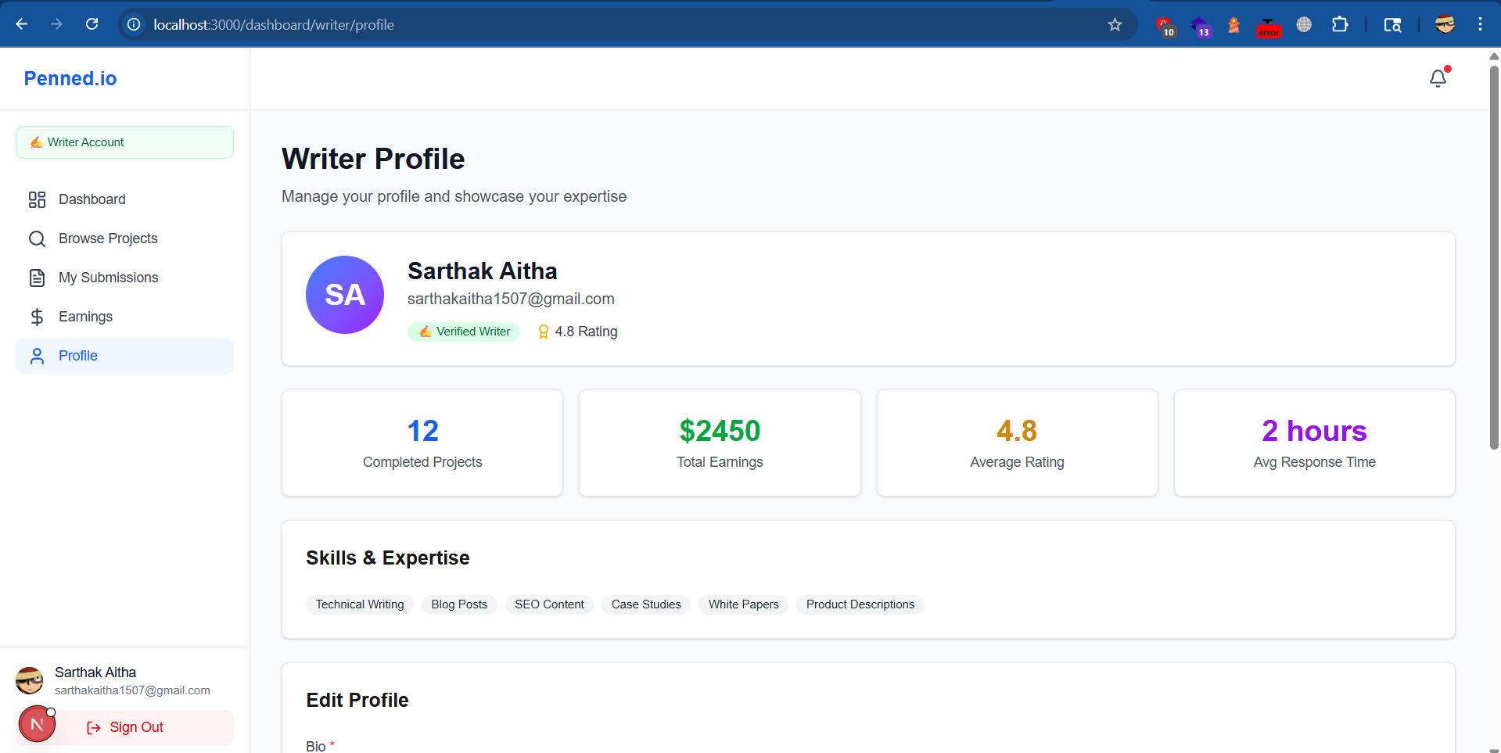

Checklist
Perfect. Below is a clean Architecture → Milestone Traceability Checklist formatted so you can paste directly into Notion, Jira, ClickUp, or Linear.
You can treat each line as:
- A Jira Epic (top-level)
- Or an Epic with child stories
- Or a Notion database with checkboxes

✅ Penned Dashboard – Architecture Traceability Checklist

🟦 EPIC 1 — Platform Foundation & Access Control

1.1 Authentication & Role Routing
- Clerk authentication implemented
- Roles: Client / Writer / Admin
- Role-based redirect after login
- Middleware route protection
- Environment variables secured

1.2 App Structure
- Single domain app routing
- Public marketing page
- Shared UI layout system
- Design system tokens established

🟦 EPIC 2 — Client Dashboard

2.1 Order Creation System
Architecture Requirements
- Content type
- Title
- Description
- Audience
- Tone
- Keywords
- CTAs
- Reference links
- Deadline
- Priority
Build Checklist
- Order form includes all required fields
- CTAs field added
- Reference links field added
- Deadline selection component
- Priority selector
- Validation logic
- Orders table schema complete

2.2 Submission Review Queue
- Client dashboard “Submission Review Queue” page
- View draft content
- Accept submission
- Request edits
- Decline submission
- Status updates reflect lifecycle

2.3 Google Docs Review Workflow (MISSING — MUST ADD)
- GDoc link field on submission
- “Open in Google Docs” button
- Store GDoc URL in DB
- Status: “In Google Review”
- Permissions model documented
- Audit log for review state changes

2.4 Feedback & Commenting
- Comment thread per submission
- Client feedback history page
- Writer-visible feedback archive
- Revision notes saved to DB

2.5 Preferred Writers (Pro Feature)
- Favorite writer functionality
- Direct assignment option
- Preferred writer filter in order form
- WriterPreferences table wired

2.6 Order & Feedback History
- Order history page
- Filter by status/date/type
- Display past feedback
- Link to past documents

2.7 Slack Account Management (Pro)
- Slack entitlement flag
- Slack instructions/portal section in dashboard
- Escalation button (if applicable)
- SLA messaging visible
- Admin override capability

🟦 EPIC 3 — Writer Dashboard

3.1 Job Marketplace
- Jobs Board page
- Filter by industry
- Filter by content type
- Filter by pay range
- Filter by client name
- Accept/claim job

3.2 Draft Submission System
- Submission form
- Attach content or GDoc link
- Status lifecycle:
  - Pending Review
  - Edits Requested
  - Accepted
  - Declined
- Resubmission workflow

3.3 Writer Ranking Table (UI MISSING — MUST ADD)
Architecture Requirement
“A ranking table for writers: points awarded for completed projects, ratings, etc.”
Must Build
- Leaderboard page/widget
- Show:
  - Points
  - Rating
  - Jobs completed
- Timeframe filter (All-time / Monthly)
- Sorting logic
- Tie-break rule
- Admin visibility toggle (if needed)

3.4 Writer Profile (Public-Facing)
- Bio section
- Expertise tags
- Industries served
- Rating
- Completed jobs count
- Portfolio links

3.5 Earnings & Wallet
- Earnings dashboard
- Transaction history
- Available balance
- Pending balance
- Wallet table wired

3.6 Payout Requests
- Payout request page
- Define payout rails:
  - Stripe Connect / ACH / PayPal
- Weekly payout logic (if required)
- Admin approval flow
- Payout status tracking

🟦 EPIC 4 — Payments & Billing

4.1 Stripe Integration
- Subscription creation
- Plan logic (Basic / Pro)
- Feature gating middleware
- Payment failure handling

4.2 Billing Dashboard
- Billing history page
- Invoice list
- Download invoice (PDF or Stripe portal link)
- Payment method management

🟦 EPIC 5 — Admin Dashboard

5.1 User Management
- View all clients
- View all writers
- Edit roles
- Suspend accounts

5.2 Order Oversight
- View all active orders
- Reassign writer
- Override status
- Flag low-quality submissions

5.3 Dispute Resolution System (PARTIAL — MUST FORMALIZE)
- Dispute status type
- Admin resolution panel
- Notes log
- Final decision action
- Refund trigger capability

5.4 Subscription & Plan Management
- Edit plan pricing
- Toggle Pro features
- Manage entitlements
- Proration handling

5.5 Content Type Catalog (MISSING — MUST ADD)
Architecture Requirement
Core Content Types vs Impact Content Types
- Admin CRUD for content types
- Seed default categories
- Order form pulls from DB
- Enable/disable categories

5.6 Platform Analytics
- Total revenue
- Jobs completed
- Active users
- Growth metrics
- Ranking distribution (optional advanced)

🟦 EPIC 6 — Platform-Wide Systems

6.1 Notification System
- Email notifications
- In-app notifications
- Status change alerts

6.2 Audit Logging
- Track status changes
- Track payouts
- Track admin overrides

6.3 Performance & Scaling
- API pagination
- Caching strategy
- Background jobs (if needed)

🔴 Critical Gaps Identified (Must Be Added to Milestones)
- Writer Ranking Table UI
- Google Docs review workflow
- Content Types catalog system
- Invoice download feature
- Explicit dispute resolution UI
- Slack Pro experience as dashboard feature
- Feedback/commenting interface
- Payout rails definition

